logo2.jpgRepublic of the Philippines

**SOUTHERN LEYTE STATE UNIVERSITY**

Main Campus, 6606, Sogod, Southern Leyte, Philippines

Telefax No.: (053) 382-3294

**Subject:** Management Information System (MM 502)

**Students:** MM CTEC 3

**Instruction:** Please read the question wisely and write your answer to your answer sheet.

1. What do you think the importance of Information technology and Information System in the field of Management?
2. In your opinion what do you think the importance of using Information system in different establishments especially in business sectors?
3. As manager what is your greatest role in Information System Security.
4. Describe briefly the five component of Information system.
5. Internet is considered as one of the latest trend in technology that gives life to different websites including Facebook. Using the figure below give the correct part of the URL. Please choose your answer from the box below.

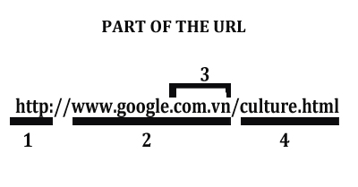

|  |
| --- |
| Protocol Document Name Uniform Resource Locator  Domain Name World Wide Web Type of Site  Website Name |

1. Good ethics is very essential in Information System because it gives them guide to act will and use Information System in proper way. Please read the situation below and give your opinion and reaction.

|  |
| --- |
| **Ethical Situation:**  Suppose that you work as a network administrator and your position allows you unrestricted access to the mailing lists for your company. Assume that you have the skill to insert your email address into any company mailing list without anyone knowing about it. You insert your address to several list and, consequently, begin to receive confidential email that no one intended for you to see. One of those emails indicates that your friend’s department is about to eliminated and all of its personnel fired. Do you forewarn your friend? why? or why not? |

Prepared by:

JAMES BRIAN FLORES, MSIT